**Replacement of a Tecate Tile roof**

In December 2019 we committed to replacing our old Tecate Tile (aka: flat Mexican tile roof). The tiles had become so fragile that any roof work resulted in broken tiles. Rain water soaked the old tiles, the roof would bleed water for days after a rainstorm. And there were a few worrisome leaks into the Adobe brick walls.

Our Larry Weir Adobe Home has a recessed central turret feature that hides the gas heater and water heater stacks, and a rainwater drain, so there is a need to climb the roof for inspection and maintenance purposes. We were actually employing a friend with a drone camera to do the checks on the turret.

Some before and after pictures are attached. We had three roofers, all recommended by our homeowners’ group, look at the job. In the end, we felt comfortable with one roofer that had experience with Larry Weir’s rotunda and turret designs, as proper flashing is critical in this area. Our roofer recommended we use Redland Clay Tile, we chose the “Baja Mission” series, which is a smaller size than the regular mission tile. It takes a while to choose a good color blend. The Redland tile sales rep. came to our house and layed out a sample square of tiles, using five different colors. He also gave us the address of homes in the area with similar tile/color patterns that he thought we might be interested in, doing a drive-by look-see. Two-piece tile use was necessary due to the rotunda feature of our house. We also went with a “fully mudded” look, some “weepy mortar” tiles, and copper flashing and rain gutters. The mud color was another decision to make. All our choices where cost uppers, and the roof cost more than the house when it was built in 1973. But it looks beautiful. The turret work was by me, lugging slump block, bullnose brick, and spec mix up on the roof, with a little help from Advil.

Our roof gas line was also rerouted and hidden under the ridge tile, by a recommended contractor from an adobe group member.

I also coasted the chimney with adobe colored Masterseal (An eggshell thin breathable concrete based paint) during the job.

If you are considering re-roofing, keep in mind there are a lot on options, and it takes time to make a decision. There’s flat tile, mission tile, S-tile, tapered turret tile, concrete or clay-based tile, as well as less expensive asphalt or composite shingle. It’s a personal decision on how you want to invest in your home, and can also be financially driven.

If you still have a Tecate tile roof and need tiles, our roofer salvaged several of them and has them available for repairs. I saved four of them with animal prints, and used them for house décor.

Feel free to contact me with any questions.

Sincerely,

Don Laverty and Valorie McClelland

310 386 4363

(Project pictures follow.)

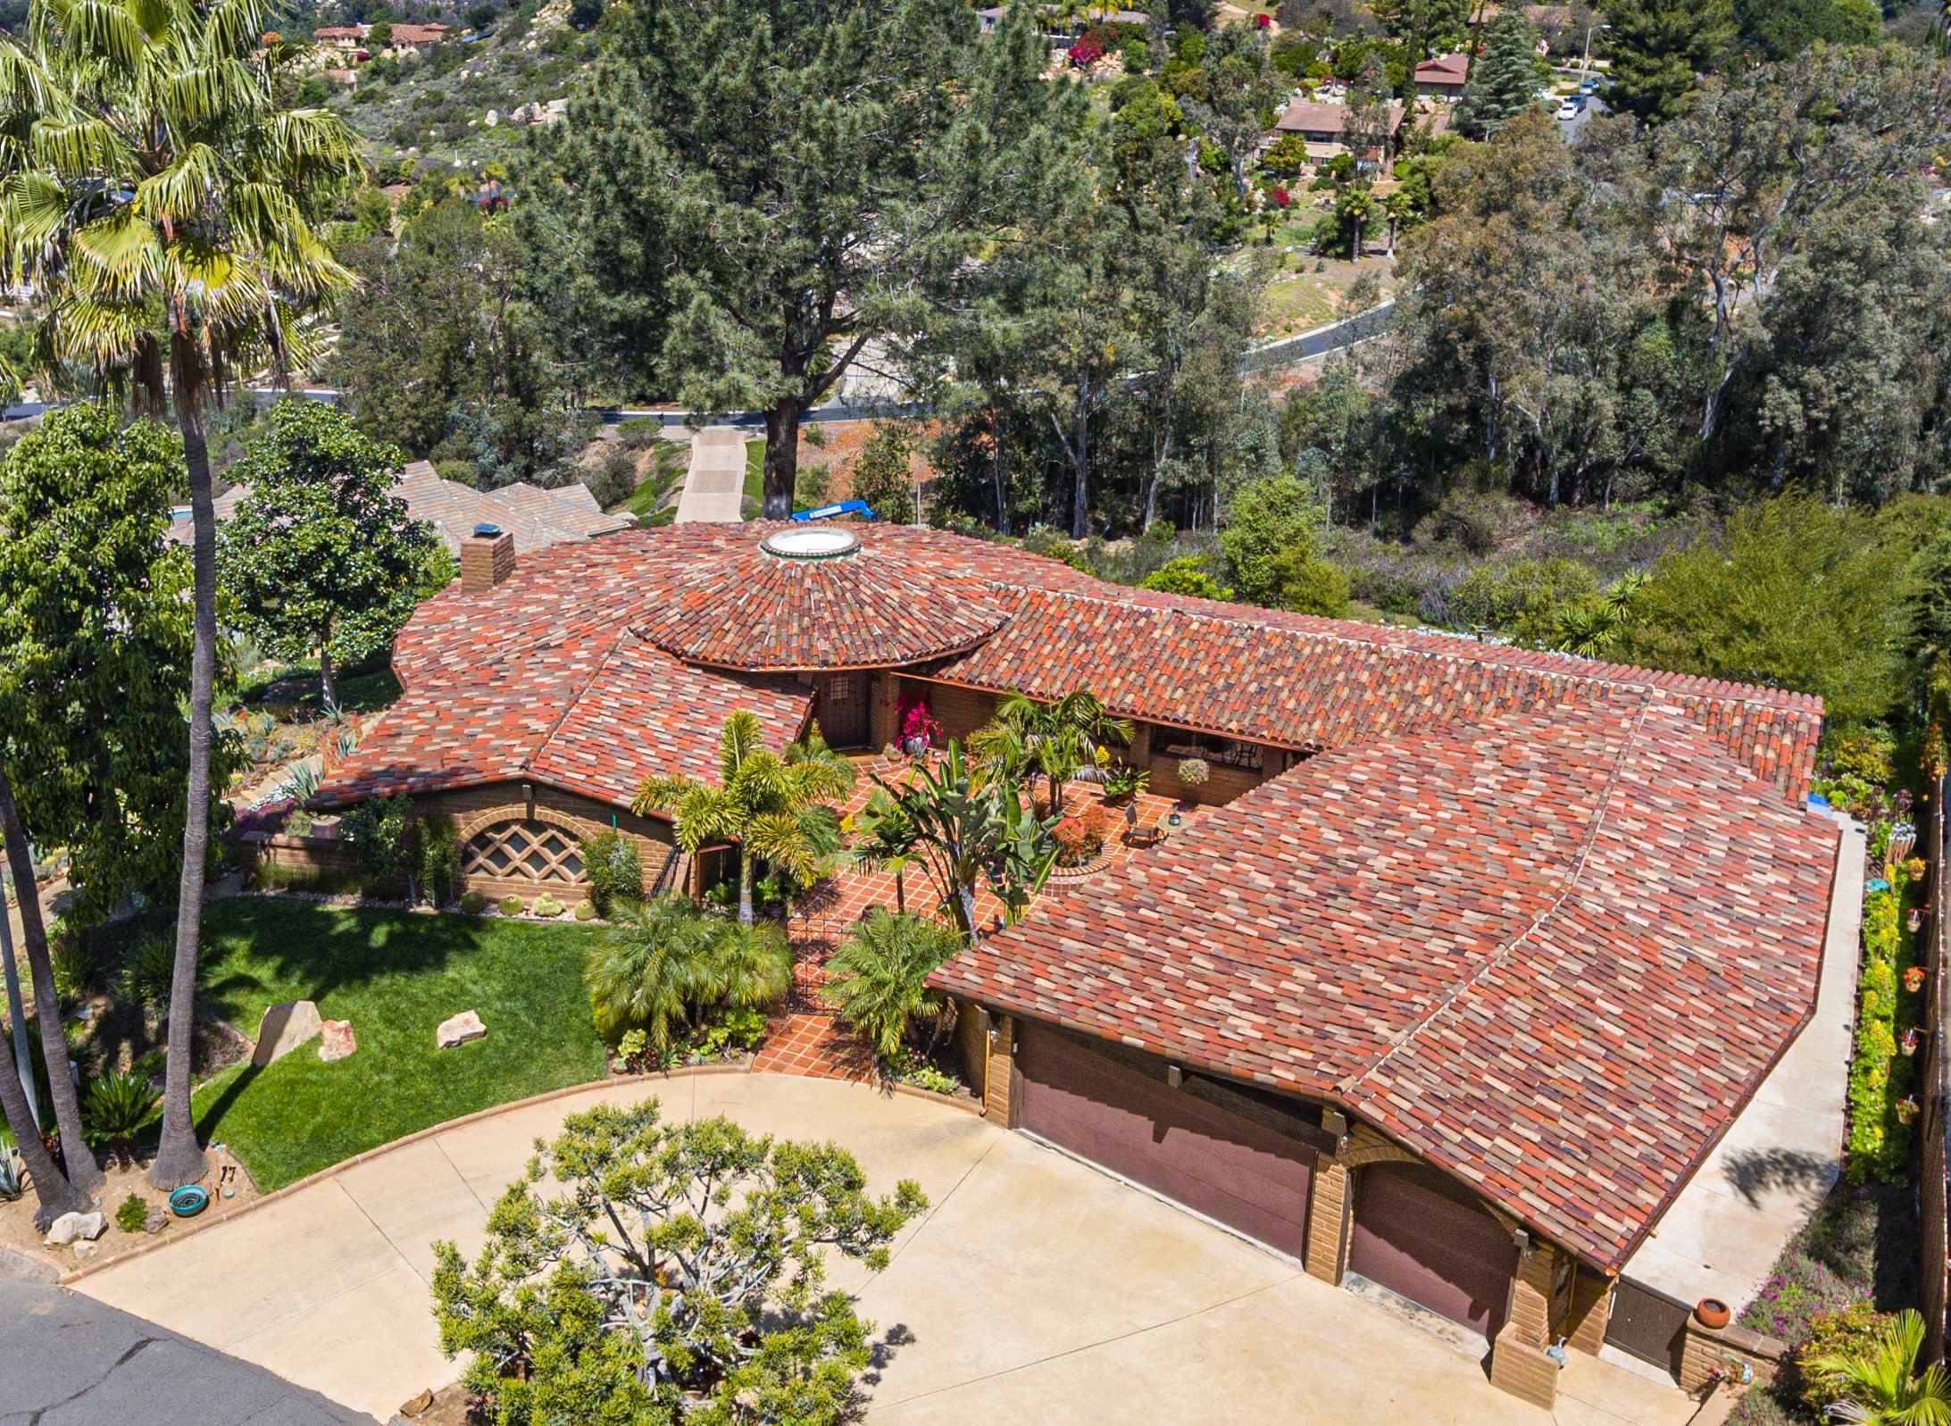

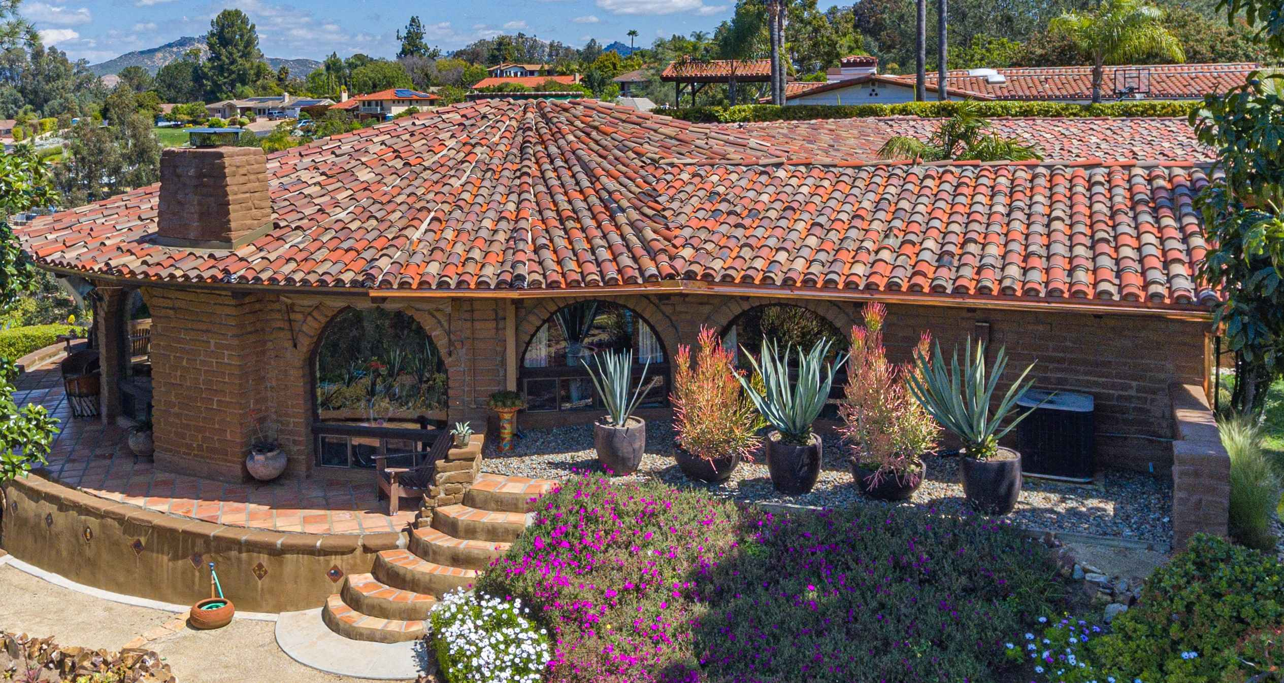

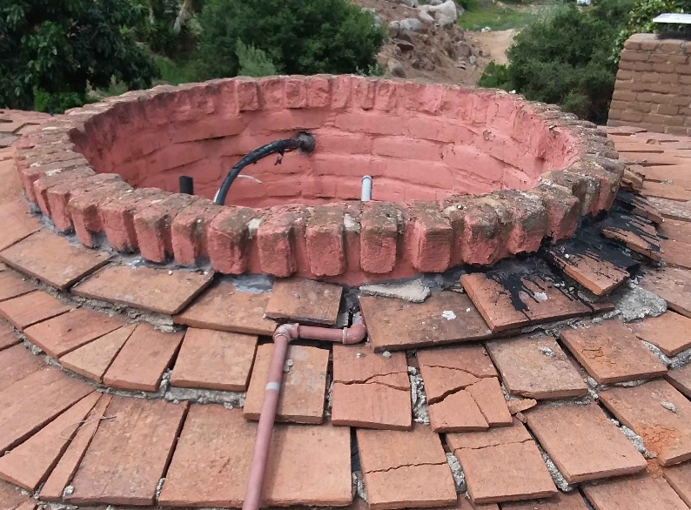

The old turret top and Tecate/flat Mexican tile

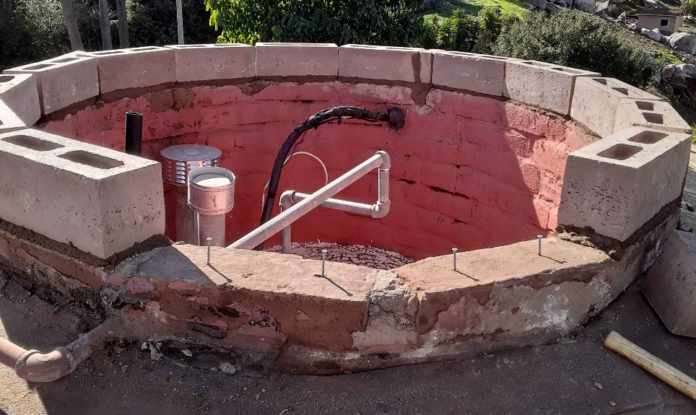

New course of slump block

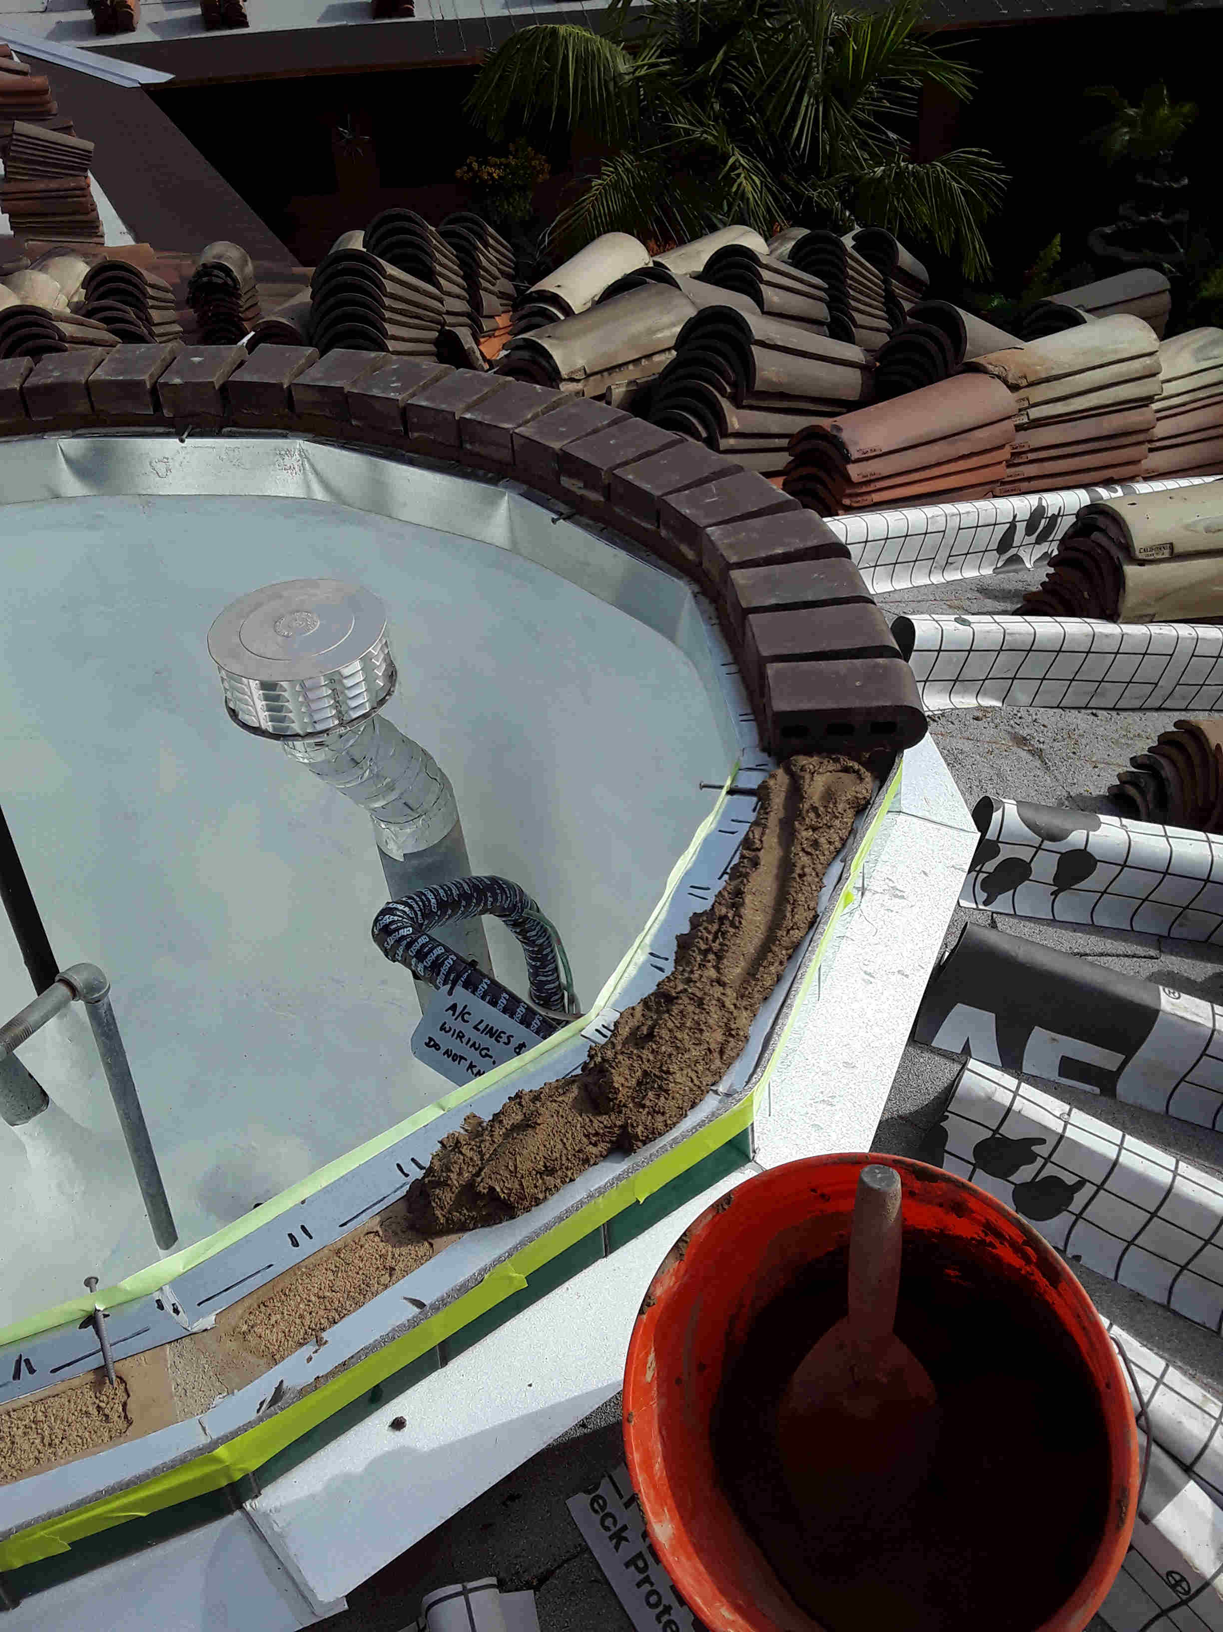

Flashing and bullnose tile going on.

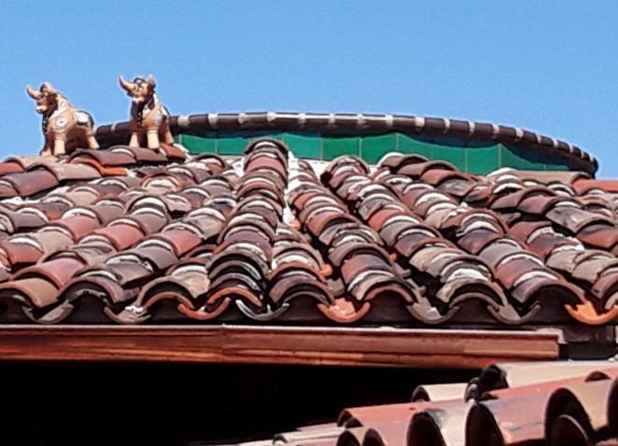

The Cusco Bulls are a Peruvian custom for good luck and prosperity.